Did God Really Say? – God Just Wants You To Be Happy
Q & A – Text 519-893-2951 or email shayne@pathwaycc.ca
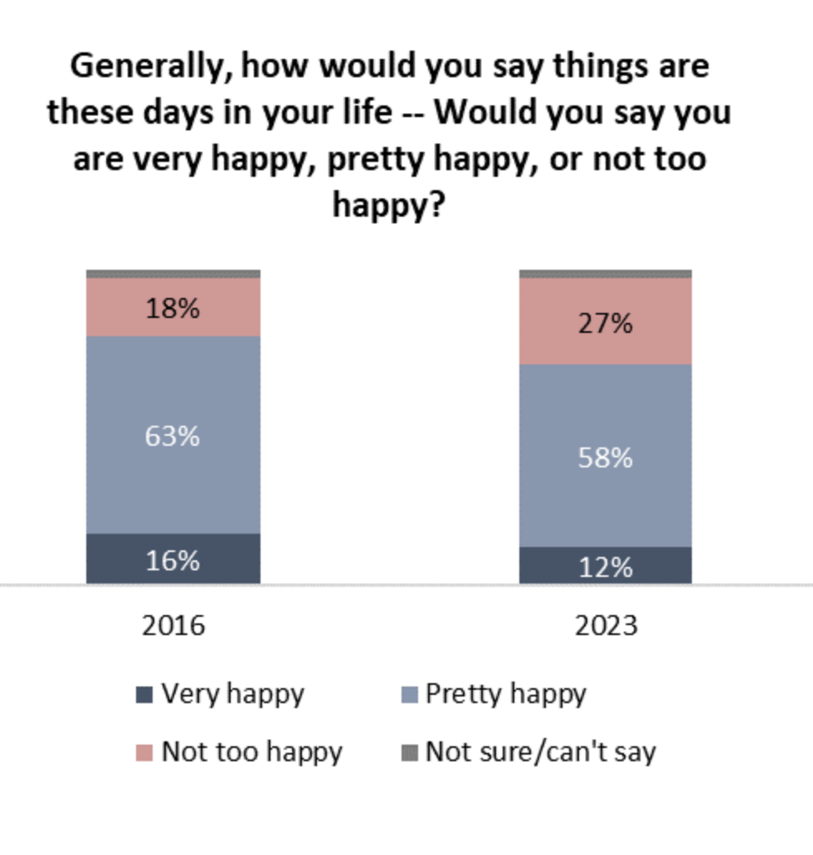
“Everyone, whatever their condition, desires to be happy.”
Augustine

We have created a ______________ ______________________
Ps 37:4, Ps 32:11, Ps 35:27, Phil 3:1, Phil 4:4-7

Our God is a ____________________ _________________.
Matthew 25:14-30

Jesus invites us to live the _________________ _____________.
John 10:10, John 15:11

There is _____________ one little problem.

When our happiness places the pleasures of the world above
following Him.
1 Pet 1:14-16, 1 John 2:15-17, Ps 1:1, Heb 13:5, 1 Tim 6:9-11

When our happiness comes at the expense of someone else.
Luke 6:32-42, Matt 22:36-40, Amos 5:11, Malachi 3:5

Take Aways:
- We have too many _______________ ______________.

- Pursuing _______________ ____________________.

LifeGroup Questions
- Spend some time sharing about your past couple weeks.
- Share a time with the group when you were really happy.
- What was something that stood out to you or surprised you about this weeks’ scriptures or sermon?
- Read Luke 15:11-32.
- What stands out to you most in this passage?
- What questions does this passage raise for you?
- What are some key things this passage teaches us?
- What are some things we can learn about God in this passage?
- What does the response of the father teach us about how we should respond to people? Is this difficult? Why or why not?
- In Luke 15 Jesus tells 3 parables. (lost sheep, coin, sons) Notice the common element in how all three end. What does this teach us? What can we learn from this regarding how we live our lives?
- Do you see any similarities between the older brother and the way the church is viewed by many in our world? Why or why not?
- Spend some time praying together as you wrap up.

